
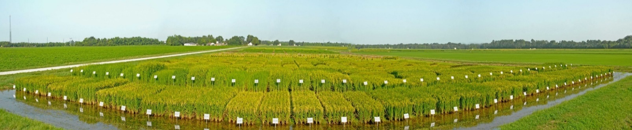
H. Rouse Caffey Rice Research Station News

Volume 16 Issue 4 - November 2019

1909-2019

56 released varieties

Rice Variety Development Update
Inside This Issue:
- Rice Variety Development Update 1-2

- Grain Smuts 3-4

- Effect of Cultural Management Practices on Greenhouse Gas (GHG) Emissions 5

- Poor Growing Conditions Were Prevalent in the 2019 Louisiana Rice Season 6

- Focus 7

Special Dates
of Interest:
- Rice Outlook Conference Little Rock, AR
December 8-10, 2019

- Rice Technical Working Group Meeting
Perdido Beach Resort
Orange Beach, AL
February 24-27, 2020

- H. Rouse Caffey Rice Research Station Annual Field Day
July 1, 2020

Contact Information:
Dr. Donald Groth
Resident Coordinator
H. Rouse Caffey
Rice Research Station
1373 Caffey Road
Rayne, LA 70578
Phone: (337) 788-7531
Fax: (337) 788-7553
https://www.lsuagcenter.com/portals/our_offices/research_stations/rice

Provisia

A new Provisia herbicide-resistant line is planned for a limited commercial release in 2021. The line will be marketed as PVL02 but was previously tested as PVL108. PVL02 is a sister line to PVL01 and has the same parentage of Cheniere crossed with the BASF Provisia donor line. PVL02 has consistently out yielded PVL01 over extensive testing during the last four years while having improved milling yields, blast resistance, and shorter maturity. It has a significantly shorter grain length than PVL01 and is slightly taller.

In 2019, the average yield of PVL02 was nearly 20% over PVL01 across 20 tests throughout Louisiana and Arkansas. In the Agronomy Project’s Variety x Nitrogen Trials, the average yield of PVL02 across five nitrogen levels (90-210 lb/A) was 8,194 lb/A (50 bbl) compared to 8,535 lb/A (53 bbl) for CL153. PVL02 is similar in days to 50% heading as CL153, CL151, and Mermentau, while being about 8 days earlier than PVL01. The average height of PVL02 is 41 in, which is slightly taller than PVL01 and CL153, which are both about 38 in.

Both PVL02 and PVL01 have a typical southern U.S. long-grain cook-type with intermediate amylose and gelatinization temperature. Both lines exhibit low chalk and are commonly among the lowest chalk lines compared to all the other varieties on the market. The grain length of PVL02 is 6.5 mm, which is significantly shorter than the very long grain of PVL01 (>7 mm). The shorter grain length of PVL02 may contributed to the improved milling yields observed compared to PVL01.

PVL02 appears to have a slight improvement on the disease package compared to PVL01, with ratings of moderately susceptible to sheath blight, Cercospora, blast, bacterial panicle blight, and the physiological disorder straighthead.

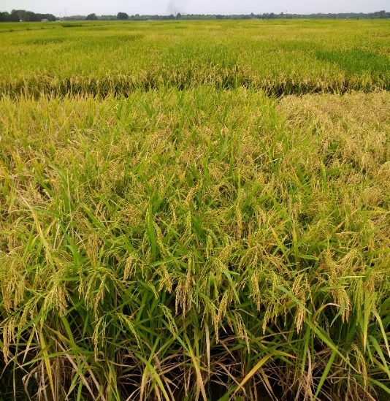

PVL02

Conventional

A conventional long-grain line, LA2140, was tested for a third year of multi-location trials and continued to show improved yields over Mermentau and Cheniere, the two most common conventional inbred varieties in Louisiana.

In 2018, LA2140 demonstrated strong yields across five locations with an average yield of 8,650 lb/A (53 bbl), out yielding CL153 and CL111 by 5% and Cheniere by 8%.

In 2019, LA2140 continued to yield well, consistently out yielding the most commonly grown varieties in research plots throughout Louisiana and Arkansas. In the Agronomy Project’s Variety x Nitrogen Trials, the average yield of LA2140 across five nitrogen levels (90-210 lb/A) was 8,894 lb/A (55 bbl) compared to 8,535 lb/A (53 bbl) for CL153. Similarly, in the Arkansas Rice Performance Test (four locations), LA2140 averaged 8,655 lb/A (53 bbl) compared to 8,520 lb/A (53 bbl) for CL153. LA2140 is similar to Cheniere in terms of maturity, height, disease resistance, and milling and has a similar amylose content as Mermentau.

In preparation for a potential release, 200 rows of LA2140 were grown last winter in Puerto Rico, and the seed was used to plant a 2-acre Foundation Seed field at the H. Rouse Caffey Rice Research Station this past season. It appeared that some outcrossing occurred in Puerto Rico, and it was decided to purify the seed in 2019 and grow Foundation Seed in 2020. A release meeting will be scheduled in the coming months for LA2140.

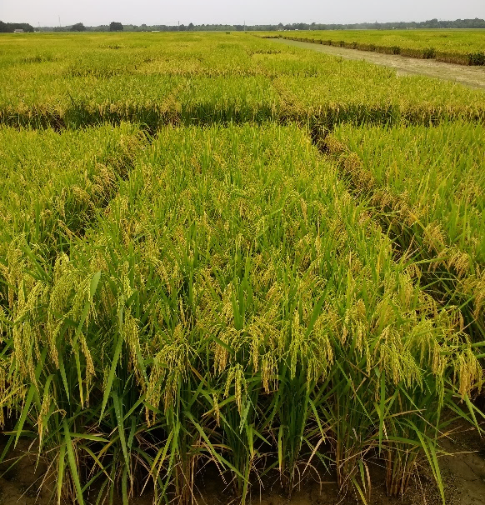

LA2140

Clearfield

A promising new Clearfield herbicide-resistant long grain, LA2097, was tested extensively in 2019 and continues to show excellent yield potential and blast resistance.

In the Agronomy Project’s Variety x Nitrogen Trials, the average yield of LA2097 across five nitrogen levels (90-210 lb/A) was 9,395 lb/A (58 bbl) compared to 8,535 lb/A (53 bbl) for CL153. Similarly, in the Arkansas Rice Performance Test (four locations), LA2097 averaged 9,029 lb/A (56 bbl) compared to 8,520 lb/A (53 bbl) for CL153.

The maturity, plant height, and seedling vigor of LA2097 are very similar to CL153. The average whole milling yield of LA2097 was 61.5% across six planting dates, which was similar to CL153 (60.8%). LA2097 has a slightly shorter grain than CL153, 6.7 mm vs. 6.85 mm. LA2097 and CL153 have very similar disease ratings for major diseases. It has very good resistance to blast in both plots and in the blast nursery and is moderately susceptible to sheath blight and bacterial panicle blight.

A release meeting will be scheduled this winter for LA2097.

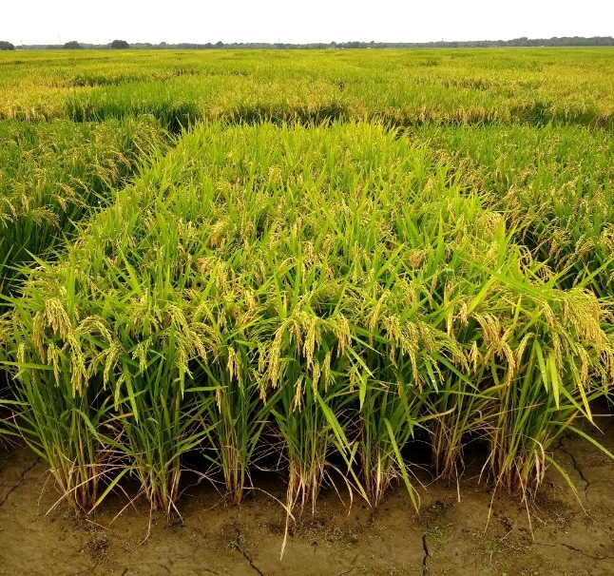

LA2097

Adam Famoso

afamoso@agcenter.lsu.edu



Grain Smuts

First crop harvest is finally finished, and several disease problems showed up that we normally do not see in south Louisiana. Kernel and false smut were present in numerous fields with higher levels than normal, causing harvest and quality problems. Several other diseases and disorders, black kernel and sooty molds, which can be confused with grain smuts, were also present. Correct identification and management of these problems are important to minimize their effect on rice production.

Kernel smut:

This fungal disease is caused by Neovossia barclayana. Symptoms are observed at or shortly before maturity. A black mass of smut spores replaces all or part of the endosperm of the grain. The disease is easily observed in the morning when dew is absorbed by the smut spores, where it is visible as a black mass (Figure 1). When this spore mass dries, it is powdery and comes off easily on fingers. Rain washes the black spores over adjacent parts of the panicle. Affected grains are a lighter, slightly grayish color compared with normal grain.

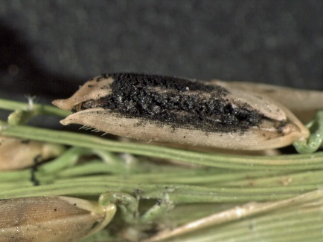

Figure 1: Kernel smut.

Usually, only a few florets may be affected in a panicle, but fields have been observed in Louisiana and Texas with 20 to 40 percent of the florets affected on 10 percent or more of the panicles in a field. Smutted grains produce kernels with black streaks or dark areas. Milled rice has a dull or grayish appearance when smutted grains are present in the sample. Because fewer kernels break when parboiled rice is milled, kernel smut can be a severe problem in processed rice. Growers are docked in price for grain with a high incidence of smut. Some varieties are more susceptible and should be avoided where smut is a problem. Spores of the fungus are carried on affected seeds and overwinter in the soil of affected fields. The pathogen attacks immature, developing grain and is more severe when rains are frequent during flowering. Propiconazole-containing fungicides applied at the boot growth stage, 2- to 4-inch panicle in the boot, have good activity against this disease. Heading applications have little or no effect on kernel smut.

False smut:

False smut, caused by the fungus Ustilaginoidea virens, is usually a minor disease in the United States but can be epidemic at times. The disease is characterized by large balls that are initially yellow then turn orange to brown-green then finally turn black. They look like balls of spores on one or more grains of the mature panicle (Figure 2). The grain is replaced by hard seed-like sclerotia. The false smut spores tend to turn black as they age and resemble kernel smut signs. They can contaminate surrounding grains. Some varieties appear to have some resistance, but hybrids tend to be more susceptible. Propiconazole-containing fungicides applied at the boot growth stage have some activity against this disease but not as good as against kernel smut.

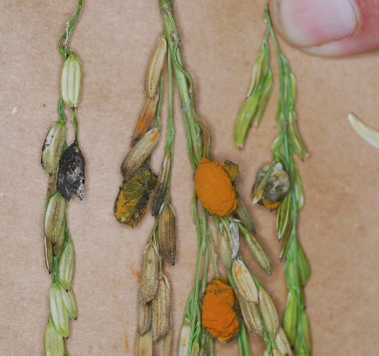

Figure 2: False smut.

Black kernel:

The fungus Curvularia lunata causes black kernel. The fungus causes severe grain discoloration (Figure 3), and after milling, the kernels appear black. The fungal spores are produced on the surface of the hulls rather than oozing out between the hulls like kernel smut. When infections are heavy, the fungus can cause seedling blights or weakened seedlings. Warm weather and high humidity favor disease development. This disease is rarely severe enough that management practices are recommended. Seed treatments to manage other diseases should reduce seedling damage. No other management measures are warranted.

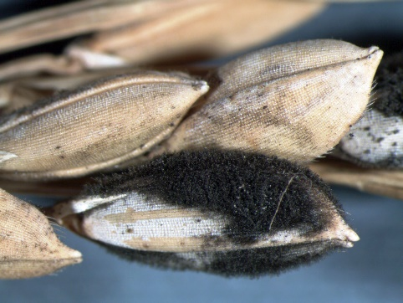

Figure 3: Black kernel.

Sooty mold:

There were several reports over the years of combines turning black from dust from the fields. Normally, this occurs when kernel smut or false smut is present in the fields. In these cases, smuts were not present. What was present was saprophytic fungi on the leaves (Figure 4) that are similar to sooty molds that form on various plants, such as citrus and azaleas. Typically, they do not form unless plants have excessive exudates or sugary honeydew secreted by insects on them. Drier conditions favor this problem since leaves are not washed by rain. They are not generally harmful, and no control methods are suggested. However, they can be a harvest problem causing large clouds of dust turning combines black.

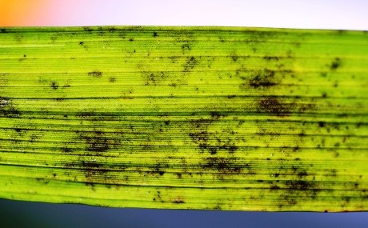

Figure 4: Sooty mold on rice leaf.

The large amounts of grain smuts this year has increased the amount of inoculum that could overwinter and affect next year’s crop. If we have favorable weather conditions again next year for grain smuts, we could have another epidemic. To reduce this risk, cultural and chemical management practices need to be adhered to reduce potential damage next year. Culturally, earlier planted rice has less smuts than later planted rice. Also, high nitrogen rates favor grain smuts and should be avoided. Chemically, fungicides with smut activity must be applied at the correct growth stage to get effective control. Only the triazole fungicides, propiconazole and difenoconazole, have good activity against smuts. The early-boot stage, 2- to 4-inch head, is critical since late boot and heading applications have little to no effect on smut development. Full labeled rates, 6 to 10 oz/A for propiconazole, should be used.

Donald Groth

dgroth@agcenter.lsu.edu

Effect of Cultural Management Practices on Greenhouse Gas (GHG) Emissions

Globally, rice production is one of the largest methane (CH₄) emission sources and accounts for 18% of the total agricultural methane emissions. Nitrous oxide (N₂O) emissions from rice fields are generally low, but cultural practices, particularly water management and nitrogen fertilizer application, can stimulate the emissions during the growing season. Current research data of CH₄ emissions in rice systems shows that the majority of emissions occur during the growing season when the fields are flooded, while the emissions of N₂O generally occur when the fields are drained and are dependent on the amount of nitrogen fertilizer applied. In addition, weather conditions and the previous crop’s organic carbon residue play a significant role in the green house gas (GHG) emissions associated with rice production. Recent reports reveal that food security and global climate change, which are correlated with GHG emissions, are being increasingly assessed with respect to crop yield.

Our studies on GHG emissions at the LSU AgCenter H. Rouse Caffey Rice Research Station (HRCRRS) are designed to evaluate the effect of cultural practices, such as water management and a ratoon cropping system, on CH₄ and N₂O emissions. The water management practices include alternate wetting and drying (AWD), an aerobic system, and furrow irrigation to be compared with the delayed-flood system, the most popular water management practice in south Louisiana. Preliminary results show that CH₄ emissions from an aerobic system and furrow irrigation were approximately 50-70% lower than the delayed-flood system, while the emissions in AWD were 10-40% lower than the delayed-flood system. The emissions of N₂O were not different among the water management practices. The disadvantage of aerobic and furrow irrigation systems was a significant yield reduction (22-30%) compared to delayed flood; however, the yield in AWD was not different from the delayed-flood practices. Due to the high level of organic carbon residue left in the field after harvesting the main crop, higher CH₄ emissions in this system were of concern. Since ratoon crop production is only practiced in the south, little emission data is available for use as a baseline for reference. The GHG emissions in the ratoon crop at the HRCRRS are currently being studied under all water management practices as mentioned above.

We found that GHG emissions are highly related with the water management practices. However, the variation in weather conditions, soil organic carbon, and other factors in the rice production system are major influencing factors. Thus, multiple years of studies are needed for better accuracy for making recommendations.

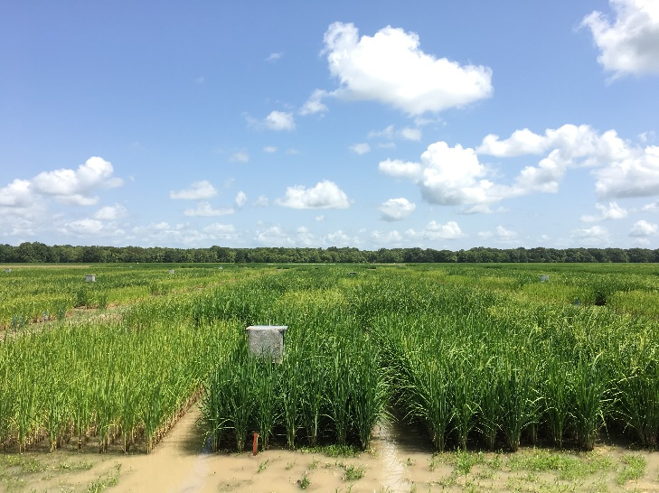

Greenhouse gas sampling in main crop.

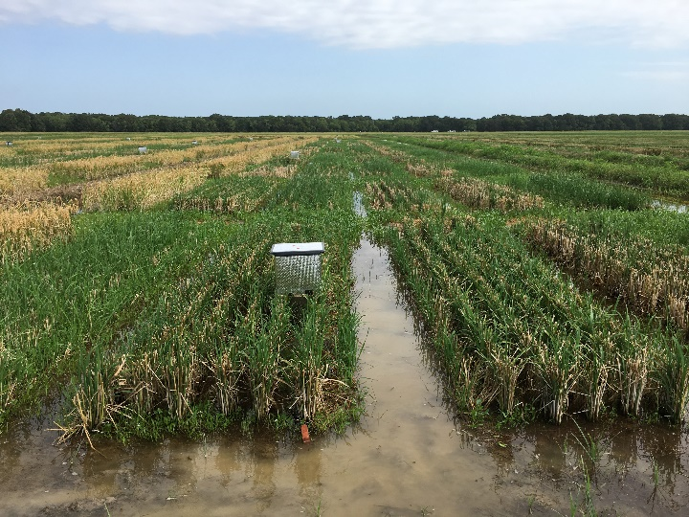

Greenhouse gas sampling in ratoon crop.

Manoch Kongchum

mkongchum@agcenter.lsu.edu

Poor Growing Conditions Were Prevalent in the 2019 Louisiana Rice Season

The one silver lining for the 2019 rice season in Louisiana was that we had a dry September, and many growers were able to work the ground and prepare for the 2020 season. It was a way to close the door on the 2019 season which, for many, was a season they would like to forget. Rice yields in Louisiana were significantly down in 2019 and so was milling on the estimated 415,000 acres harvested. Many growers in southwest Louisiana reported that their farms were seeing a yield reduction anywhere between a 10 to 40% across the farm. Reduced yields were also reported in northeast Louisiana but not to the extreme reductions observed in the southern portion of the state. Current NASS estimates have the projected state yield average at 6,650 lb/A.

There are many factors that contributed to the poor rice yields this year. In fact, you could say that there were poor growing conditions from the beginning to the end of the season. After harvest in 2018, the ground remained saturated, preventing cultivation and land preparation for the 2019 season so most of the seedbed preparation occurred just prior to planting. Planting began in earnest the third week of March when the soils dried, and we had approximately a 2-week window that drill planting occurred. The bulk of the rice was planted in this window. On April 4, the first of a handful of storms brought excessive rainfall to the region that overtopped young and emerging rice.

Rice emergence and development were slow and uneven due to the cold wet soils. Rice fields throughout the region had spotty stands, and it was common to see 3-leaf rice and rice just emerging from the ground. While this in itself does not seem that bad, it does make agronomic decisions difficult. Proper herbicide application, flood establishment, nitrogen application, and other decisions are dependent on the proper rice growth stage and can negatively affect yield at the end of the season.

Once most rice was fertilized and flooded, another large rainfall event occurred which flooded and overtopped several rice fields. Only a few acres were completely lost due to the flooding. However, a lot of the rice in the region was once again stressed while submerged. Some growers also opted not to apply more nitrogen fertilizer after draining their fields to allow the rice to recover. It is critical to maintain the flood immediately after fertilizing and flooding rice for 3 weeks after application to allow the rice to take that nitrogen up and be utilized. If a field is drained and oxygen is reintroduced to the system, the ammonium nitrogen can be converted to nitrate nitrogen which will be lost after reflooding the rice. Therefore, it is critical to apply more nitrogen if this occurs.

One of the biggest things that reduced yield in 2019 was Hurricane Barry that made landfall on July 11. Pre-landfall predictions had rainfall estimates of over 25 inches. Thankfully, most of the rice in southwest Louisiana received much less rain than that. Since most of the rice was in the early stages of heading, flooding at that point could have been a major disaster for Louisiana rice. However, Barry did bring with it rain and a lot of wind. A good portion of the rice in the region was flowering at the time. Rain and wind can disrupt flowering and cause the grain to blank. Since Barry was a slow-moving storm, we had several days where pollination was disrupted, and yield was lost. The blanked grain was also a vector for increased disease pressure later in the season.

At harvest, black kernel smut and false smut were excessive in southwest Louisiana, so excessive in some cases that trucks containing excessive levels of smut were turned around at multiple grain facilities. Historically, smuts have not been prevalent in southwest Louisiana, and preventative applications of propiconazole fungicides at the 2- to 4-inch panicle in the boot growth stage are rarely used. Due to the epidemic levels of the smuts in 2019, more applications will need to be applied in the future if we want to properly manage smuts.

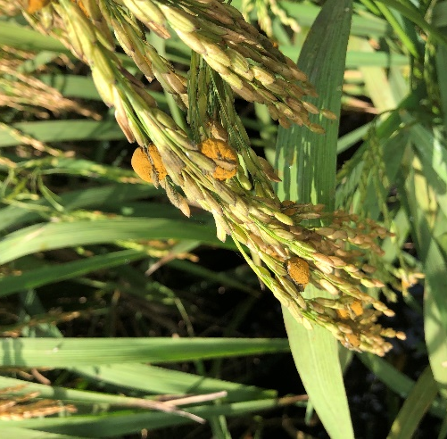

False smut on grains of rice.

Dustin Harrell

dharrell@agcenter.lsu.edu

Focus

Tara Roy

Tara Roy’s dream came true when she started working at the H. Rouse Caffey Rice Research Station in December 2018.

“I grew up in a small rural community, and I always wanted a job in agriculture,” she said. “Getting this job was an honor because I now can give back to Louisiana agriculture.”

As a girl, she recalled, when she was not in school, she would go to the farm owned by her grandparents in Forked Island where they raised cattle, poultry, sheep, pigs, horses, and crawfish.

“I was there basically all of my childhood,” she said. “Just about every waking moment I was there, and when I wasn’t, I’d beg to go.”

Her work in the Hybrid Breeding Program as a research farm specialist involves planting, growing, and harvesting the crop, then milling it. In the winter, she is working in the greenhouse.

Her boss, Dr. Jim Oard, LSU AgCenter hybrid rice breeder, said Tara is an asset to his program. “Tara is a hardworking and conscientious worker in the field, greenhouse, and laboratory. She is quickly gaining experience in operation of field equipment and research that benefit the Hybrid Breeding Program.”

Tara graduated from Comeaux High School in Lafayette in 2005. She worked for an oilfield supply company before starting her job at the H. Rouse Caffey Rice Research Station.

On weekends, she works at a dog daycare facility in Broussard and with the St. Martin Humane Society. She has six dogs, two cats, and six ducks.



Bruce Schultz

bschultz@agcenter.lsu.edu

  The LSU AgCenter H. Rouse Caffey Rice Research Station is on Facebook. The page will provide timely updates on research conducted at the station as well as other useful information. The page can be accessed at the link below. Simply go to the page and click on LIKE. Updates will then be posted to your Facebook newsfeed. If you are not currently a user of Facebook, signing up is easy and free.  https://www.facebook.com/LSU-AgCenter-H-Rouse-Caffey-Rice-Research-Station-212812622077680/ |  |   Online Store  Visit the LSU AgCenter online store at the following website to purchase our publications or view free ones.  https://store.lsuagcenter.com/default.aspx

This newsletter is produced by Valerie Dartez, Bruce Schultz, Donald Groth, and Darlene Regan.

